76

Staff Development Tool on Recreational Activities
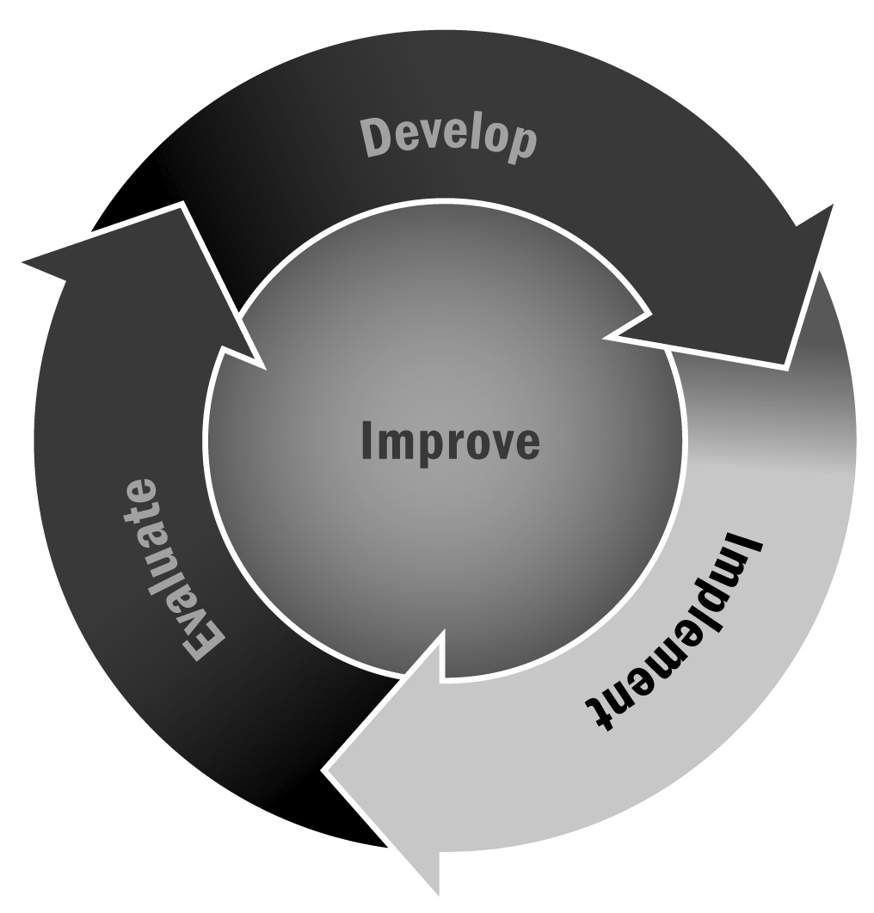
In Chapter 4, you learned that recreational activities play an important role in promoting healthful, active lifestyles for youth. Recreational activities that incorporate physical fitness or movement can encourage positive values, improve social skills, teach responsibility, and promote lifelong healthy habits.
Directions: Staff members can use this tool in conjunction with Tool 71: Sample Activity Planner to develop high-quality recreational programs. For each activity being offered, answer the questions to help your program meet the characteristics of high-quality recreational activities listed below.

Characteristics of High-Quality Recreational Activities
- They offer a variety of fun, age-appropriate, and culturally relevant activities based on community interest.
- They create a sense of belonging for youth (i.e., activities are developed to eliminate isolation and comparison of youth).
- They have fair and consistent rules.
- They are challenging but positive.
- They promote physical as well as social and emotional development.
- They promote youth development (e.g., staff members build on the strengths and address the developmental needs of youth, and teach youth positive self-talk).
- They are run by positive, enthusiastic staff members who actively participate in the activities.
- They focus on teamwork and leadership rather than competition.
- They allow youth opportunities to lead and coach.
- Is the activity age appropriate and culturally relevant? In what ways?
- How will you make the activity fun?

- How will you create a sense of belonging for youth? How will you foster inclusion and a positive environment in the program?

- In what ways is your activity challenging?

- In what ways do you promote teamwork? A positive attitude?

- Describe your program’s rules. Are they fair and consistent?

- How do you promote physical development in your program?

- How do you promote social and emotional development in your program?

- What experience do program staff members have? Who will be the lead staff member? How do staff members get involved in the program?

- What opportunities do you provide for youth to lead or coach?

